Lab 4 documentation

1. Project Infrastructure
- Directory Setup: You created a structured project environment with dedicated folders for the product-service and order-service.
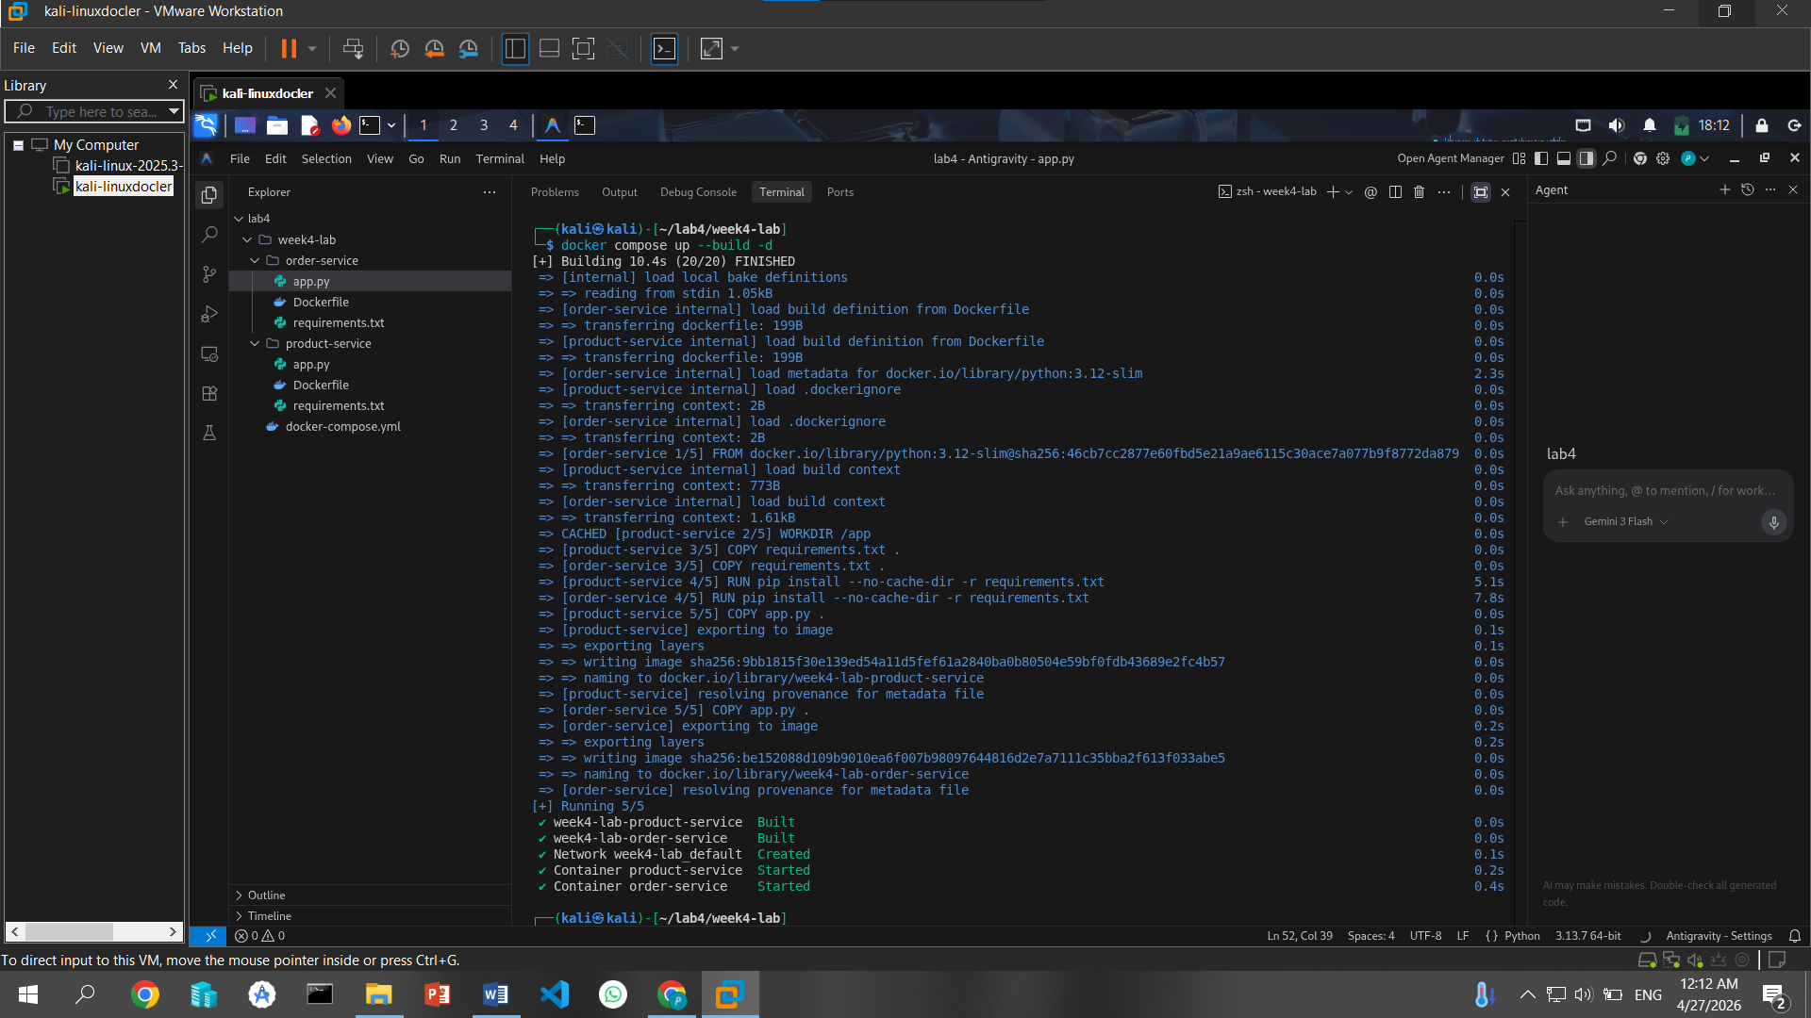
- Dependency Management: You defined the necessary Python libraries for each service using requirements.txt files.

2. Service Development
- Product Service: You built a Flask API that serves as a stateless data provider, returning product details from an in-memory catalog.
- Order Service: You implemented a service that communicates synchronously with the product service, featuring built-in retry logic and timeouts for basic resilience.

3. Containerization and Orchestration
- Dockerization: You created custom Dockerfiles for both services, ensuring they are packaged independently as small, cloud-native images.
- Compose Configuration: You configured docker-compose.yml to handle service discovery, environment variables, and health checks.
- System Deployment: You successfully built and launched the entire stack using docker compose up --build -d.

4. Functional & Resilience Testing
- API Verification: You confirmed that both services are "healthy" and that the order-service can successfully fetch data from the product-service to process an order.
- Failure Injection: You simulated a real-world outage by stopping the product-service and observed the order-service handle the failure by returning a 503 error after its retries failed.
